**BACHELOR OF SCIENCE INDIA’S**

**MATHEMATICS AGRICULTURAL CROP**

**PRODUCTION**

**ANALYSIS 1997-2021**

** Teammates:**

**DEPARTMENT OF SCIENCE S.Asmitha**

**Raja Doraisingam Government Arts& M.Durgashree**

**Science College K.Nandhini**

**SIVAGANGAI -630561 M.Kowsalya**

**INDIA’S AGRICULTURAL CROP PRODUCTION**

**ANALYSIS 1997-2021**

**Overview:**

*Introduction:*

- Provide a brief overview of the significance of agriculture in India's economy.

- State the objective of the analysis, which is to examine crop production trends over the past 25 years.

**Production:**

*Cereal Production:*

- Discuss the trends in cereal production (rice, wheat, maize) during the specified period.

- Highlight the factors contributing to changes in cereal production, such as technology adoption and government policies.

*Pulses Production:*

- Examine the trends in the production of pulses and the reasons behind production fluctuations.

*Oilseeds Production:*

- Analyze the production of oilseeds (e.g., soybeans, groundnuts) and the factors affecting production, including weather conditions and global prices.

*Horticulture:*

- Discuss the growth in fruit and vegetable production, emphasizing the factors driving this expansion.

*Sugarcane Production:*

- Explore the trends in sugarcane production for sugar and ethanol and the yearly variations in production.

*Cotton Production:*

- Investigate the growth in cotton production and its link to the textile industry.

*Factors Affecting Production:*

- Discuss the key factors influencing crop production, such as monsoon patterns, government policies, technology, and global market conditions.

*Challenges:*

- Address the challenges facing Indian agriculture, including sustainability, land degradation, water scarcity, and climate change impacts.

.

**PROBLEM STATEMENT:**

"Analyzing the trends in India's agricultural crop production from 1997 to 2021 to identify key factors influencing fluctuations, predict future yields, and propose strategies for sustainable agricultural growth."

**ANALYSIS:**

Certainly, here are additional points to elaborate on the problem statement:

1. *Data Collection and Analysis*: This study involves collecting and analyzing historical data on crop production in India from 1997 to 2021, including information on crop types, regions, and annual yields.

2. *Identifying Factors*: The analysis aims to identify the various factors influencing crop production, such as climate, soil quality, government policies, technology adoption, and market dynamics.

3. *Trend Analysis*: The study will focus on identifying trends and patterns in crop production over the years, including variations in crop yields and shifts in dominant crops in different regions.

4. *Predictive Modeling*: Developing predictive models to forecast future crop yields based on historical data and identified influencing factors. This can aid in better crop management and food security planning.

5. *Sustainability Assessment*: Assessing the sustainability of current agricultural practices and proposing strategies for more sustainable and environmentally friendly crop production.

6. *Policy Recommendations*: Based on the analysis, the study will provide policy recommendations to government authorities and agricultural stakeholders to enhance agricultural productivity and food security.

7. *Economic Implications*: Examining the economic implications of crop production trends, including their impact on rural livelihoods, food prices, and national GDP.

8. *Geographical Variability*: Recognizing regional variations in crop production and proposing region-specific strategies for optimization.

9. *Technology Adoption*: Evaluating the adoption of modern agricultural technologies and their impact on crop yields.

10. *Climate Resilience*: Investigating the effects of climate change on crop production and suggesting strategies to build resilience.

**EMPATHY MAP:**

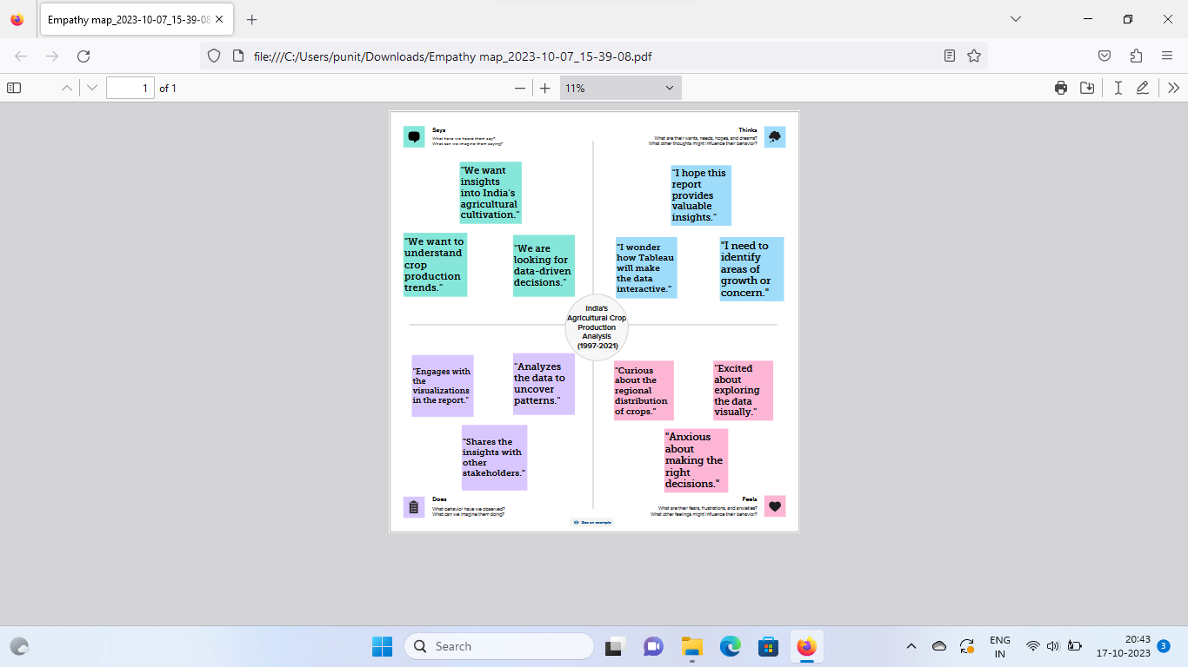

**BRAINSTORMING MAP:**

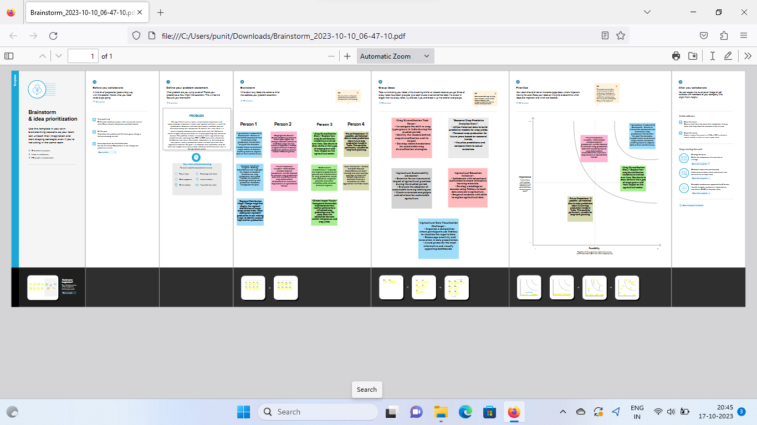

**ADVANTAGES:** Analyzing India's agricultural crop production from 1997 to 2021 offers several advantages:

1. *Policy Evaluation*: It allows for an assessment of the effectiveness of government policies and initiatives aimed at boosting agricultural productivity and supporting farmers.

2. *Identifying Trends*: Long-term analysis helps identify trends in crop production, which can inform future policies and investments.

3. *Climate Resilience*: Understanding the impact of climate change and extreme weather events on crop production is essential for building resilience in the agricultural sector.

4. *Sustainable Agriculture*: It provides insights into the adoption of sustainable and organic farming practices, which are increasingly important in the context of environmental sustainability.

5. *Regional Disparities*: Analysis can highlight regional variations, which can inform targeted interventions to address disparities in crop production and income.

6. *Food Security*: Assessing crop production is critical for ensuring food security for India's growing population.

7. *Crop Diversification*: It helps in understanding the success and challenges of crop diversification efforts, which can reduce risks associated with mono-cropping.

8. *Market Dynamics*: Insights into crop choices can inform market strategies and trade policies.

9. *Agricultural Research*: Analysis can guide agricultural research by identifying areas where innovation is needed.

10. *Economic Impact*: Understanding the economic impact of agriculture on the nation's economy, including its contribution to the GDP and job creation.

11. *Socio-Economic Implications*: It can shed light on the socio-economic implications of crop production, including the livelihoods of farmers and rural development.

12. *International Comparisons*: It allows for comparisons with other countries and provides insights into India's position in the global agriculture sector.

Overall, analyzing India's agricultural crop production over this period is crucial for evidence-based decision-making, improving food security, and ensuring the sustainability and profitability of the agricultural sector.

**DISADVANTAGES:**

Analyzing India's agricultural crop production from 1997 to 2021 also comes with certain disadvantages and challenges:

1. *Data Quality*: Historical agricultural data may not always be accurate or consistent, which can affect the reliability of the analysis.

2. *Data Gaps*: Some regions or crops may have incomplete or missing data, making it challenging to provide a comprehensive analysis.

3. *Changing Definitions*: Definitions and measurement methods for agricultural data may change over time, making it difficult to compare data from different years.

4. *Complexity*: Agriculture is a complex sector influenced by multiple factors, and isolating the impact of specific variables can be challenging.

5. *Time Lag*: There is typically a time lag in the availability of agricultural data, making it difficult to provide real-time analysis.

6. *Economic Factors*: Crop production is influenced not only by agricultural practices but also by economic factors like market prices and trade policies.

7. *Limited Scope*: An analysis may not capture the full range of factors affecting agriculture, such as the impact of land use changes or urbanization.

8. *Regional Variability*: India's diverse agro-climatic zones mean that crop production varies significantly by region. A national-level analysis may not capture these regional nuances.

9. *Long-Term Trends*: A study limited to 1997-2021 may not fully capture long-term trends, which can span decades or even centuries.

10. *Complex Interactions*: Various factors like technology, policy, and climate interact in complex ways, making it difficult to attribute changes in crop production solely to one cause.

11. *Subjectivity*: The interpretation of data can be subjective, and different analysts may arrive at different conclusions.

12. *Lack of Real-Time Data*: This analysis is based on data available up to September 2021. To make real-time decisions, you would need up-to-date information.

Despite these disadvantages, analyzing India's agricultural crop production remains valuable, but it's essential to consider these limitations when drawing conclusions and making policy decisions. Researchers often use statistical techniques and modeling to address some of these challenges.

**SOME IMPORTANT POINTS:**

Certainly, here are some additional points related to India's agricultural crop production analysis from 1997 to 2021:

*Rice and Wheat Dominance*: Rice and wheat have consistently been the dominant crops in terms of production and consumption. Government policies like the Green Revolution and procurement support have contributed to this.

*Crop Diversification*: Over the years, there has been a shift towards crop diversification as farmers have started to grow a wider variety of crops, including high-value crops like fruits and vegetables.

*Technological Advancements*: The adoption of modern agricultural practices, including the use of hybrid seeds, mechanization, and improved irrigation, has played a significant role in increasing crop yields.

*Government Initiatives*: Various government schemes, such as the Pradhan Mantri Fasal Bima Yojana (PMFBY) and the National Agriculture Market (eNAM), have aimed to mitigate risks for farmers and improve market access.

*Climate Impact*: Climate change has had both positive and negative effects on crop production. Changing weather patterns, including erratic rainfall, have posed challenges for Indian agriculture.

*Organic Farming*: There has been a growing interest in organic farming, with an increasing number of farmers adopting organic practices and certification.

*Export Opportunities*: India has become a major exporter of agricultural products, including rice, spices, and fruits. Trade policies and international demand play a crucial role in this.

*Sustainability Concerns*: Sustainable agricultural practices, soil health management, and water conservation have gained importance to ensure the long-term viability of Indian agriculture.

*Crop Diseases and Pests*: The agriculture sector has had to deal with various crop diseases and pest infestations, leading to fluctuations in crop yields.

**FUTURE SCOPE:**

The future of agriculture in India holds several opportunities and challenges. Here's a glimpse of the future scope:

1. *Technological Advancements*: Continued advancements in agricultural technology, such as precision agriculture, the use of drones, and AI-driven farming, can enhance productivity and resource efficiency.

2. *Sustainable Practices*: The adoption of sustainable and eco-friendly farming practices will likely become more critical to address environmental concerns and ensure long-term food security.

3. *Agri-Exports*: India can further expand its agricultural exports by focusing on quality improvement, adhering to international standards, and exploring new markets.

4. *Value-Added Products*: There's potential for value addition in the agriculture sector by processing raw agricultural produce into products with higher value, like food processing and agribusiness.

5. *Organic Farming*: The demand for organic products is rising globally. India's large arable land and growing interest in organic farming present opportunities in this segment.

6. *Startups and Agri-Tech*: The emergence of startups and agricultural technology companies in India can lead to innovative solutions in areas like farm management, supply chain, and market access.

7. *Climate-Resilient Crops*: Developing and adopting climate-resilient crop varieties can help mitigate the impacts of changing weather patterns.

8. *Rural-Urban Linkages*: Strengthening the connection between rural and urban areas can facilitate better market access, reduce post-harvest losses, and improve the livelihood of farmers.

9. *Government Initiatives*: Ongoing and new government schemes to support farmers, such as income support and insurance, will continue to shape the agriculture sector.

10. *Skill Development*: Investing in training and skill development for farmers can enhance their ability to adapt to modern practices and technologies.

11. *Water Management*: Efficient water management, including rainwater harvesting and drip irrigation, is crucial in a country prone to water scarcity.

12. *Global Collaboration*: Collaborating with other countries on agricultural research, trade agreements, and knowledge sharing can benefit India's agriculture sector.

However, it's important to address challenges like land degradation, access to credit, and equitable distribution of benefits to ensure sustainable growth in Indian agriculture. Additionally, the sector's resilience in the face of climate change and evolving market dynamics will be pivotal in determining its future success.

**CONCLUSION:**

Summarize the key findings from the analysis.

Highlight the overall trajectory of India's agricultural crop production during the specified period.

Mention the significance of this analysis in understanding India's agricultural sector

**RESULT:**

